* BANKING HISTORY

1. **History –**

The Indian Banking System traces sack its history to 1786. When the first bank in India (The General Bank of India) Was established. From that year till today the journey of growth of the Indian Banking system can be divided into three phases –

Phase I (Early Phase from 1786 to 1969 of Indian Banks)

Phase II (Nationalisation of Indian Banks and up to 1991 prior to Indian Banking Sector Reforms)

Phase III (New Phase of Indian Banking System with the advent of Indian Financial and - Banking Sector Reform After 1991)

1. **Gift Economy –**

A gift economy is an economic system based on gift-giving, in which goods or services get exchanged with no expectation of remuneration, reciprocity, or quid pro quo. This system differs from a market economy, in which individuals exchange goods and services for money, or a barter economy, in which goods and services get exchanged for items or services of equal value.

1. **Central Bank –**

A national bank that provides financial and banking services for its country's government and commercial banking system, as well as implementing the government's monetary policy and issuing currency.

RBI is the central bank for India.

Reserve/Central banks in other countries

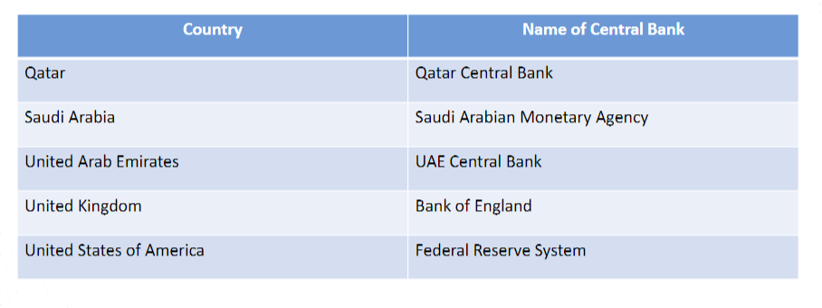

1. **Indian Banking System –**

Key laws to control and regulate banking in India -  
▪ The Reserve Bank of India (RBI) Act, 1934 – Empowers RBI, the central bank of India, to control and regulate the banking business  
▪ Banking Regulations Act 1949 – Defines the business of banking, its rules and regulations  
▪ Negotiable Instruments Act 1881 – Rules to deal with negotiable instruments - cheques, bills of exchange and promissory notes.  
▪ Bankers’ Books Evidence Act 1891 – for record keeping of banking transactions.  
▪ Foreign Exchange Management Act 1999 – Foreign exchange to facilitate external trade and payments, investment avenues for NRIs and foreign direct investment in India.  
▪ “Payment and Settlement System Act 2002 - Provides for regulation and supervision of payment systems in India".

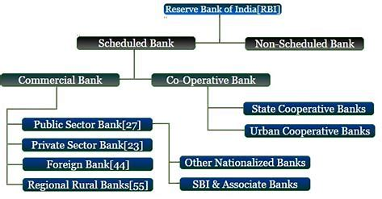

**FUNCTIONS**

Essential for daily bank operations.  
▪ Combines back-end and front-end processes.  
▪ "Core" stands for "Centralized Online Real-time Exchange."  
▪ Establishes a centralized network for a bank and its branches.  
▪ Enables customers to access and manage accounts at any branch.  
▪ Centralized data center created by core banking software.  
▪ Services include deposit accounts, loans, payments, and more.  
▪ Accessible through ATMs, internet banking, mobile banking, and physical  
branches.  
▪ Utilizes Information Communication Technology to streamline banking  
procedures.

**TYPES OF BANKS –**

* Central Bank – Govern a country’s money supply, monetary policy, and often issue currency.
* Retail Banks – Focus on serving individual customers, providing services like savings, and checking accounts.
* Cooperative Banks – Owned by their members, who are typically customers and shareholders.
* Commercial Banks – Offer a range of services to individuals, businesses, and governments.
* Investment Banks – Primarily deal with large financial transactions, mergers, acquisitions, and trading.
* Development Banks – Aim to support economic development projects in various sectors.
* Islamic Banks – Operate according to Islamic principles, avoiding interest and following Sharia law.

*Sharia Transactions are interest free

*Non-Sharia transactions are interest based

* Online Banks – Operate primarily or exclusively online, without physical branches.
* Credit Unions – Member-owned financial cooperatives that provide similar services to traditional banks.

1. **Business Model –**

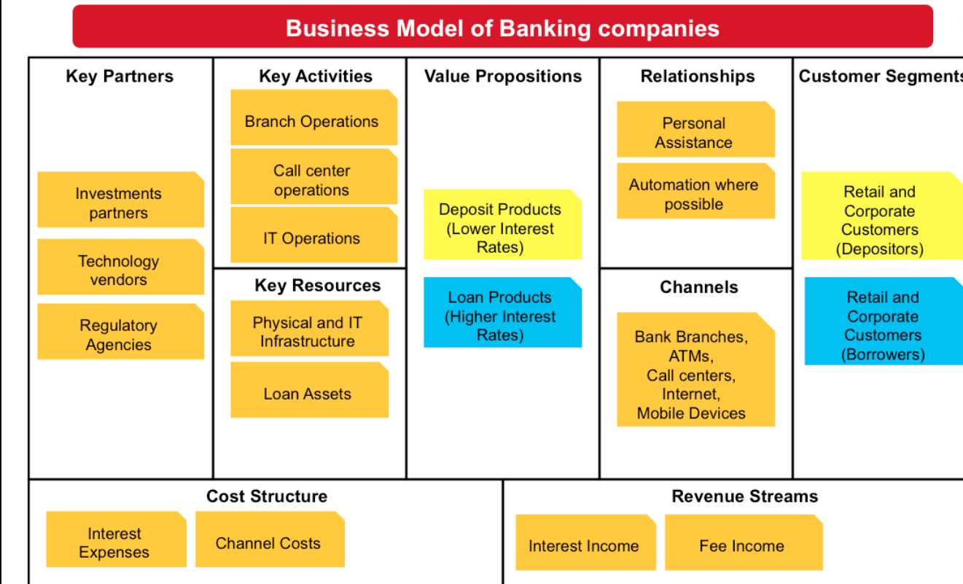

1. **Cooperative & Commercial Banks –**

|  |  |  |
| --- | --- | --- |
|  | **Cooperative Banks** | **Commercial Banks** |
| **Ownership And Examples** | Owned and controlled by their members who are also customers.  Ex – Baroda city cooperative bank, Saraswat Cooperative bank, Punjab, and Maharashtra cooperative bank | Owned by shareholders and investors who may or may not be customers.  Ex – SBI, ICICI Bank, HDFC Bank |
| **Purpose** | Primarily focus on meeting the financial needs of their members. | Operate for profit, aiming to maximize shareholder value by providing a variety of services to public. |
| **Customer Base** | Serve a more localised community or specific group of members who share a common bond. | Serve a broader customer base, including individuals, businesses, and government entities. |
| **Decision Making** | More democratic as members do voting for major decisions. | Decision made by a board of directors and management with less input from customers. |
| **Profit Distribution** | Profits are often reinvested in the banks or among members. | Profits are distributed to shareholders in the form of dividends. |
| **Regulation** | Governed by cooperative laws and regulations, with oversight from regulatory authorities. | Subject to banking regulations and oversight by financial regulatory bodies. |

* RETAIL LIABILITIES

1. **Retail Banking Overview –**

* Retail banking: also known as consumer banking /personal banking, is banking that provides financial services to individual consumers rather than businesses.​
* Retail banks can be local community banks or the divisions of large commercial banks.​
* Retail Banking Services are provided to individuals in the GENERAL PUBLIC.​
* Corporate Banking Services are only provided to SMALL OR LARGE COMPANIES AND CORPORATE BODIES.​

**Services of Retail Banking**

* Banking Deposits and Loans and advances.​
* Types of accounts maintained. ​
* Payments services ​
* Bill Pay ​
* VISA ​
* NEFT (Electronic funds transfer) ​
* Smart Payment ​
* Remittance Services Collection and Clearance services

1. **Products and Services –**

* **Debit Card**

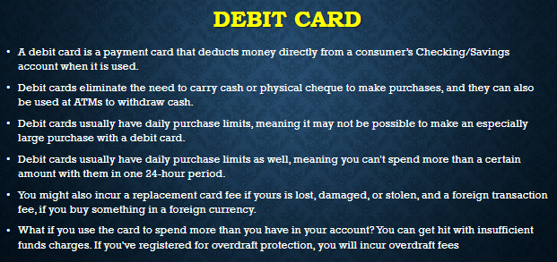

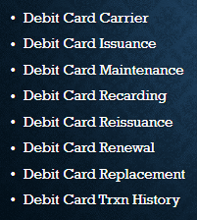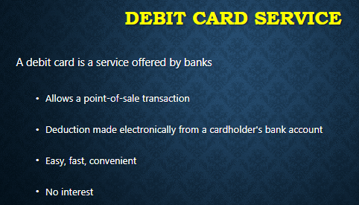

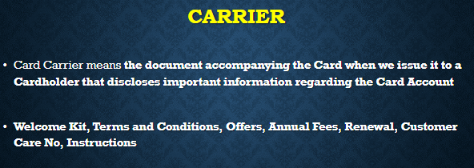

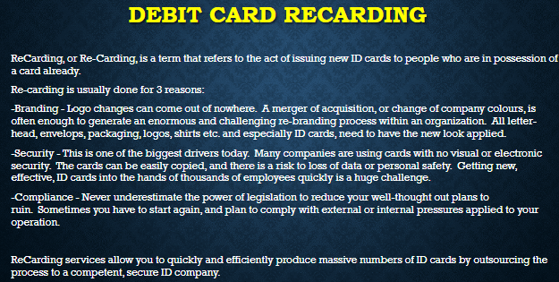

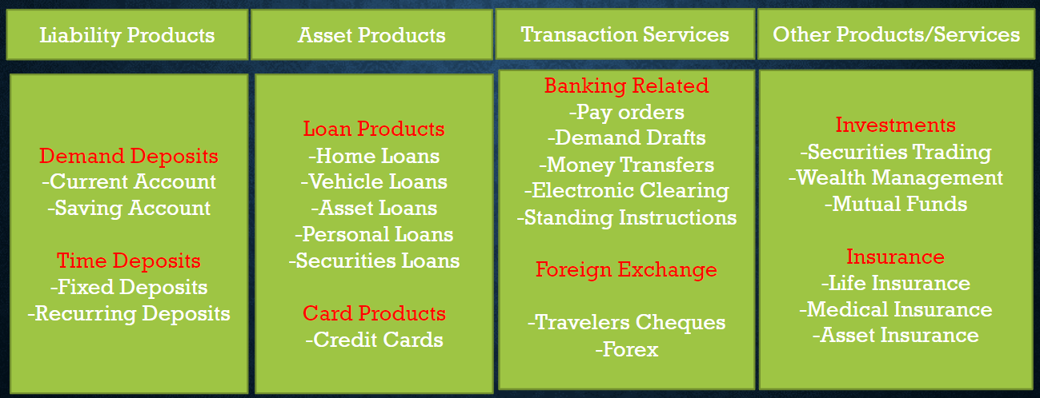

**Two types of Products**

**Liability Products & Asset Products.**

* **Liability Products –**
* DEMAND DEPOSITS​

CURRENT / CHECKING ACCOUNT​

SAVINGS ACCOUNT​

* TERM DEPOSITS​

FIXED DEPOSIT​

RECURRING DEPOSIT

|  |  |
| --- | --- |
| **CURRENT ACCOUNT​**  **​**   * **Used by entrepreneurs, business people, etc.​** * **No limits for transactions​** * **No interest​** * **Overdrawing is available.​** * **Minimum balance to be maintained is high​** | **SAVINGS ACCOUNT​**  **​**   * **Used by general public​.** * **Allows only limited transactions​.** * **Interest is low​.** * **No overdrawing facility​** * **Minimum balance to be maintained is low​** |

|  |  |
| --- | --- |
| **FIXED DEPOSIT​**   * **Used for depositing lump sum amount at one time​.** * **Tenure ranges from 7 days to 10 years​** * **Interest is high than RD​.** * **Interest gets credited on quarterly/monthly or on maturity​.** * **Loan can be availed​** | **RECURRING DEPOSIT​**   * **Used for depositing small amounts but on regular basis​.** * **Tenure ranges from 6 months to 10 years​.** * **Interest is low than FD​.** * **Interest is paid on maturity along with capital amount​.** * **Loan can be availed​** |

* **Asset Products –**

​

* Home Loan​

Long-term. Low IR​

* Vehicle Loan​

Loan includes road tax, reg. and insurance​.

* Asset Loan​

Secured Loan. Borrower pledges asset as​

collateral. High Loan amount with Low IR​

* Personal Loan​

Unsecured Loan. 1-84 Months. High IR​

* Gold Loan​

Immediate Capital, No collateral. Low IR​

* Education Loan​

To be paid after completion​

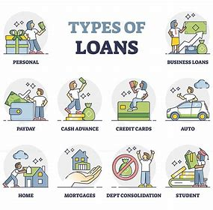

**Loan Life Cycle**

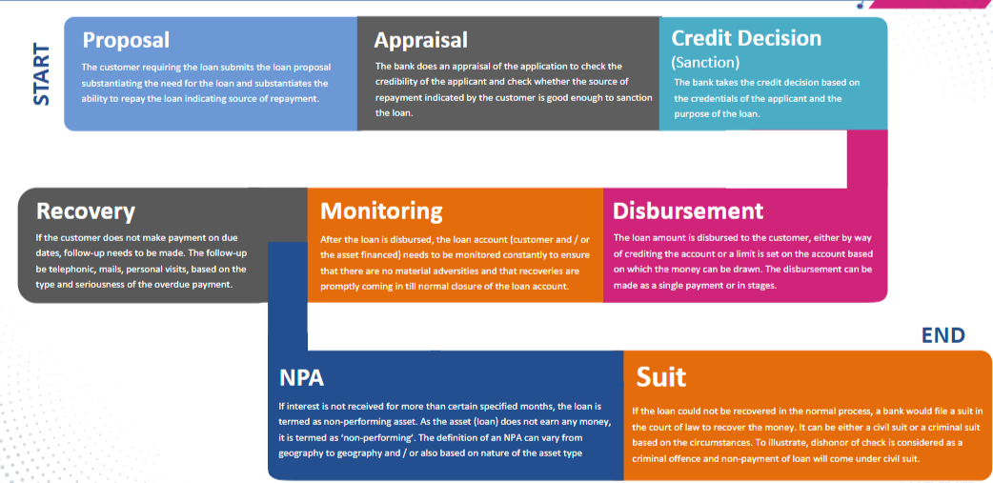

**CREDIT CARDS**

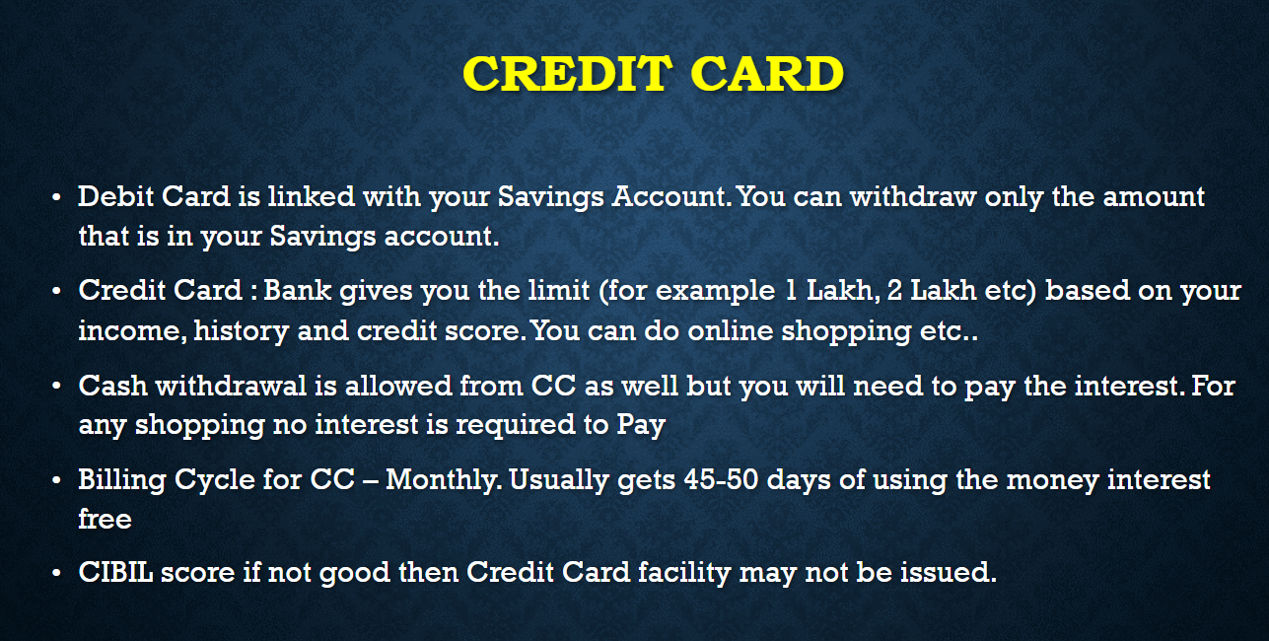

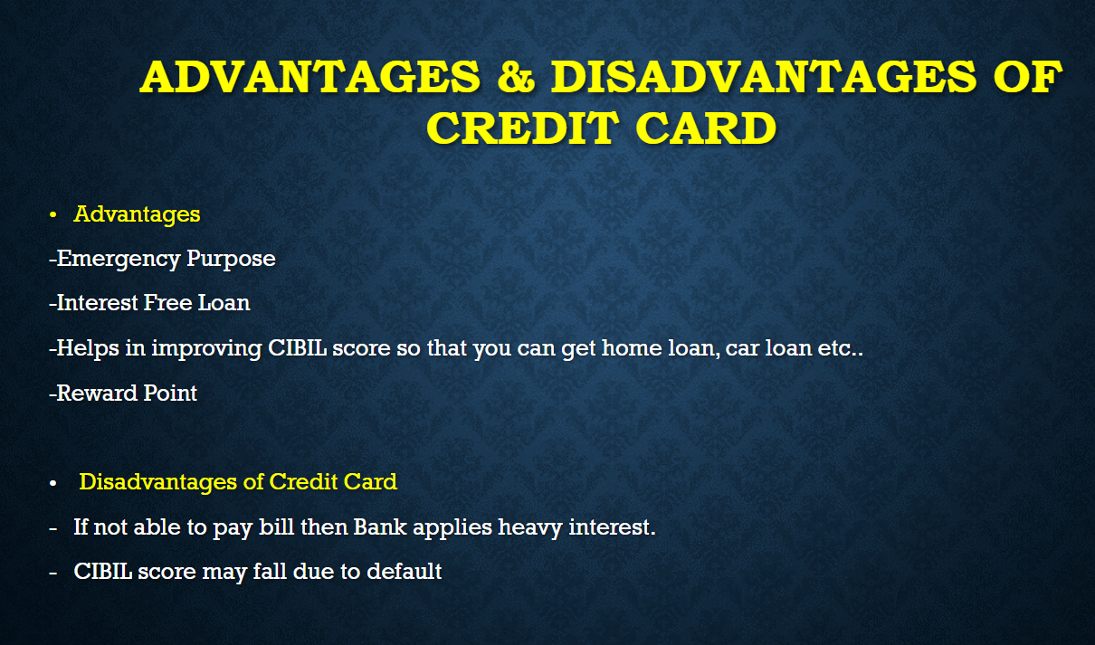

**TRANSACTION SERVICES**

* Pay order. ​

 (Once ordered cannot be cancelled)​

* Cheque ​

 (Acc pay & Non Acc pay)​

* Demand Draft ​

 (Issued by bank)​

* Money transfer ​

(NEFT, IMPS, RTGS) ​

* Mobile banking ​

 (App services for remote transactions)​

* Standing Instructions ​

 (Auto debit- diff online subscription platforms/account)​

* Foreign Exchange ​

 (Travel cheque, Forex cards, Travel credit cards)​

|  |  |
| --- | --- |
| **Forex Cards​** | **Travel Credit Cards​** |
| * Less issuance cost (100 to 500)​ * Prepaid​ * Currency fluctuations doesn’t affect​ * zero Mark-up fee​ * No lavish premium benefits​ | * Issuance cost is high (3000-5000)​ * Not prepaid/credit limit​ * Currency fluctuation effects​   ​   * Mark-up fee Exists​ * Lavish premium benefits​ |

1. **Savings and Current Accounts – Features**

**CIF – Customer Information File**

* Electronic file containing customer’s personal and account data.
* Provides a CIF number for identification.
* Enables business to access customer accounts based on relationships, not just account type.
* Includes client’s credit relationships, owned accounts, and ownership details.

**Savings Account**

▪ Interest-bearing deposit account held at a bank or financial institution.  
 ▪ Offers modest interest rates but prioritizes safety and reliability.  
 ▪ Ideal for short-term cash needs and emergencies.  
 ▪ Provides easy access to funds.  
 ▪ Yields lower interest compared to other savings and investment  
 options.  
 ▪ Eligible for all resident Indian customers aged 18 and above.  
 ▪ Can be opened through branch visits or online banking.  
 Savings Account

**Features of Savings Account**

▪ A Savings bank account is a safe place to store surplus funds  
 ▪ The balance in a savings account earns interest.  
 ▪ Savings account interest rates on savings account can range from  
 3.5% to 7% p.a.  
 ▪ Easy access to internet banking and mobile banking  
 ▪ Most banks also provide savings account holders with various  
 insurance covers including personal accidents and death.  
 ▪ ATMs can be used all across India with your debit card.  
 ▪ Cheque Book facility

**Current Account**

▪ Maintained by individuals with frequent transactions.  
 ▪ Allows payments to creditors using checks.  
 ▪ Typically requires a higher average minimum balance than savings  
 accounts.  
 ▪ Offers overdraft facility up to an agreed limit.  
 ▪ Also known as demand deposit accounts.  
 ▪ Generally does not earn interest and may incur fees for banking  
 services.

**Features of Current Account**

▪ A current account allows transactions beyond the scope of a savings account  
 ▪ Compared to savings account, a current account requires a higher minimum balance  
 ▪ It is designed to facilitate frequent transactions – transfer funds, receive cheques, cash, etc.  
 ▪ A current account can be operated by individuals, proprietary concerns, public and private  
 companies, associations, trusts, etc.  
 ▪ No restriction on the number of transactions in a day  
 ▪ Non-maintenance of the minimum balance can attract penalty charges  
 ▪ There cannot be multiple current accounts for a single customer

* **NRE & NRO Accounts**

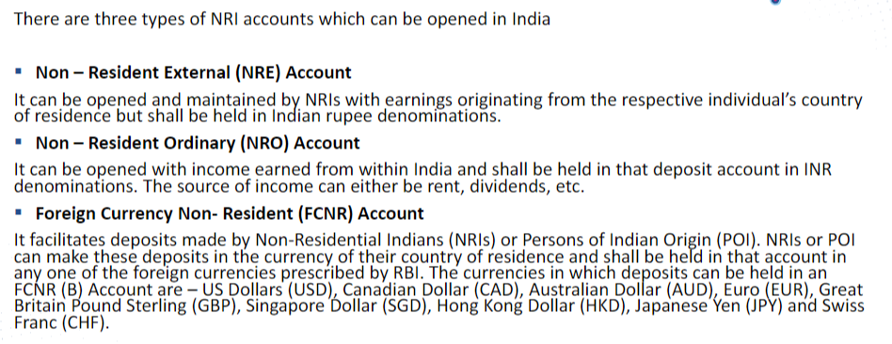

**Difference between NRE, NRO & FCNR Accounts**

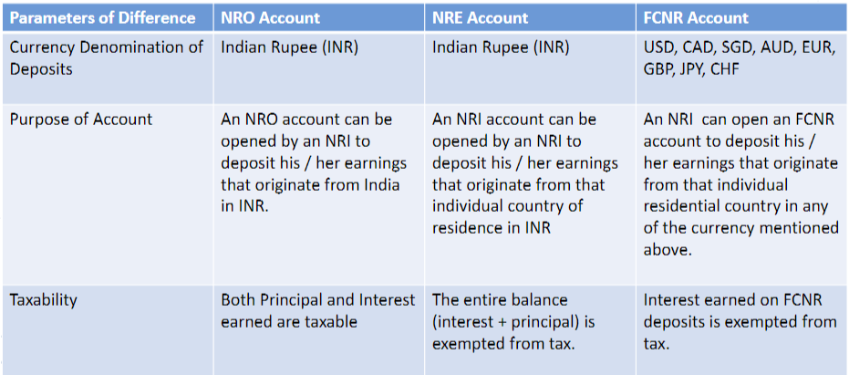

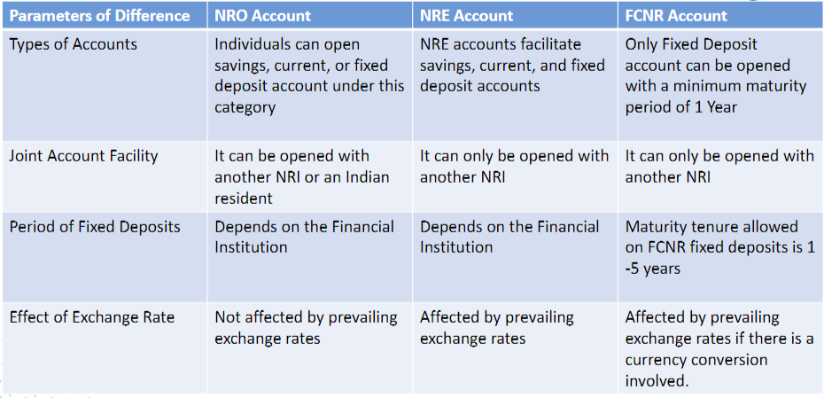

1. **Advances – Cash Credit, Discounting & Overdraft**

**Cash Credit**

➢ Is short-term funding or loan for a company so that it can meet its working capital requirements offered to businesses.  
➢ Is an arrangement whereby the bank allows the borrower to draw amount up to a specified limit.  
➢ Available for the customer’s account.  
➢ The customer can withdraw this amount as and when he requires.  
➢ The interest is calculated on the total amount of the credit allowed.  
➢ Cash Credit is granted as per terms and conditions agreed with the customers.  
➢ This is also known as ‘Revolving Credit’.  
➢ the inventory and receivables of a business work as security for allowing a cash credit facility

**Overdraft**

➢ The overdraft facility allows the withdrawal of excess amounts in case of insufficient bank balance.  
➢ Is also a credit facility granted by bank and sanctioned for a specific period; stands cancelled after due date  
➢ Overdraft facility can be rolled over if the customer desires & the Bank agrees to do  
➢ A customer who has a current account with the bank is allowed to  
withdraw more than the amount of credit balance in his account  
➢ It is a temporary arrangement. The interest is calculated on the amount  
overdrawn  
➢ One can extend this facility by taking shares, other investments like FDs,  
and insurance policies as security.  
➢ Overdraft facility with a specified limit may be allowed either on the  
security of assets, or on personal security, or both  
➢ Account becomes NPA if the balance remains in debit without any  
repayment beyond certain past due days as decided by RBI

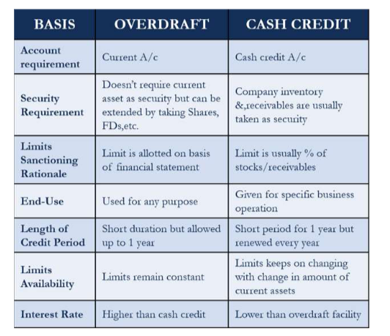

**Discounting**

➢ Banks provide short-term finance by discounting bills  
➢ Under this type of lending, Bank takes the bill drawn by borrower on his (borrower's) customer and pay him immediately deducting  
some amount as discount/commission.  
➢ Making payment of the bill before realization of the same after deducting a certain amount of discount at a defined rate of interest  
➢ The customer gets the funds without waiting for the date of realization of the bill  
➢ For example, a dollar received 50 years from now may be valued less than a dollar received today—discounting measures this  
relative value.  
➢ In case any bill is dishonoured without being paid on presentation, the bank can recover the  
amount from the customer including the charges towards the bill being returned unpaid.  
➢ Cheque /Demand Draft/Pay Order/Banker’s Cheque is called ‘clean bill whereas the set  
of documents containing ‘bill of exchange’/Hundi, commercial invoice, Railway / Semi  
Truck /Airway receipt etc., is known as ‘documentary bill’. Documentary bills are  
generally backed by LC (Letter of Credit)  
➢ Bill discounting either for clean bill or documentary bill is facilitated against adequate security.

1. **Deposit Services – Types & Features**

* DEMAND DEPOSITS​

CURRENT / CHECKING ACCOUNT​

SAVINGS ACCOUNT​

* TERM DEPOSITS​

FIXED DEPOSIT​

RECURRING DEPOSIT

|  |  |
| --- | --- |
| **CURRENT ACCOUNT​**  **​**   * **Used by entrepreneurs, business people, etc.​** * **No limits for transactions​** * **No interest​** * **Overdrawing is available.​** * **Minimum balance to be maintained is high​** | **SAVINGS ACCOUNT​**  **​**   * **Used by general public​.** * **Allows only limited transactions​.** * **Interest is low​.** * **No overdrawing facility​** * **Minimum balance to be maintained is low​** |

|  |  |
| --- | --- |
| **FIXED DEPOSIT​**   * **Used for depositing lump sum amount at one time​.** * **Tenure ranges from 7 days to 10 years​** * **Interest is high than RD​.** * **Interest gets credited on quarterly/monthly or on maturity​.** * **Loan can be availed​** | **RECURRING DEPOSIT​**   * **Used for depositing small amounts but on regular basis​.** * **Tenure ranges from 6 months to 10 years​.** * **Interest is low than FD​.** * **Interest is paid on maturity along with capital amount​.** * **Loan can be availed​** |

* RETAIL ASSETS
  1. **Retail Assets Products Overview –**

**Two types of Products -**

**Classification of Loans**

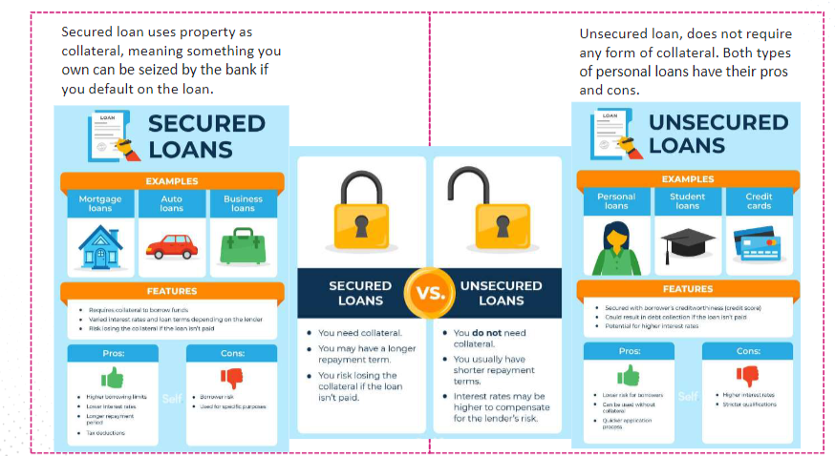

**Types of Loans**

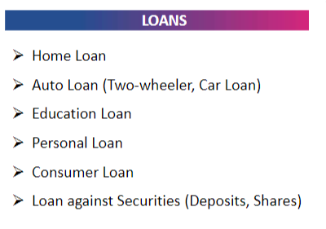

**Types of Interests**

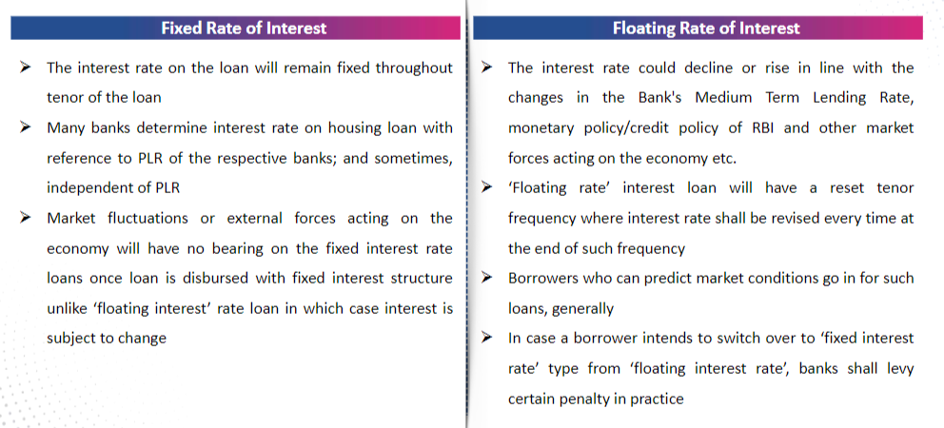

* 1. **Credit Origination System for Individuals –**

**7 Stages of Loan Origination System**

➢ Carrying out documentation from the loan application to the loan disbursal stages.  
 Ensuring DDE (Detailed Data Entry), KYC OCR verification, eligibility checks, offer and fee  
 collection (subject to offer confirmation from the customer), credit appraisal, credit  
 approval, and loan disbursal.  
 ➢ Pre-qualification Check – Borrower’s ID & Address Proof, Income & Employment Status,  
 Credit Score, Bank Statement and Previous Loan Statement if any  
 ➢ Application – Form of Paper-Work / Digital Platform  
 ➢ Application Processing – Instant process it can flag files, return it to borrowers, and

notify the relevant department.

➢ Underwriting – Analyze financial information & allocate funding through credit score,

risk score & other outstanding loans.  
 ➢ Credit Decision – is the result of underwriting, happens through AI-powered software  
 ➢ Quality Check - The lender validates the internal and external regulations at this stage

on the application before the funding.  
 ➢ Funding - After all the documents are verified and signed, the lender makes the funds  
 available.  
 ➢ Note: Depending on the types of loans, the origination process differs.

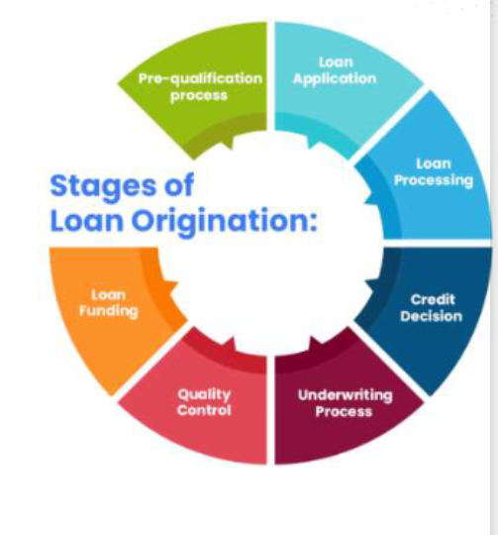

* 1. **Understanding the workflows and Business rule engine–**

**Workflows:**

1. Account Opening
2. Loan approval
3. Transaction processing
4. Fraud detection

**Business Rules:**

1. Risk management
2. Compliance
3. Interest rates and fees
4. Customer eligibility
5. Security and access control

**Combination of workflow and business:**

1. Loan approval workflow
2. Transaction processing
3. Customer onboarding workflow

**4. Key Business Process in Credit Origination System –**

1. **Application Intake and Data Capture:**
   * Capture basic applicant information, including personal details, financial information, employment details, and other relevant data.
   * Gather supporting documents, such as income statements, bank statements, and identification documents.
2. **Application Validation and Verification:**
   * Validate the accuracy and completeness of the information provided by applicants.
   * Verify applicant data through external sources, such as credit bureaus, to assess the applicant's credit history and risk profile.
   * Authenticate the identity of the applicant to prevent fraud.
3. **Credit Scoring and Decisioning:**
   * Assign a credit score to each applicant based on their credit history, financial status, and other relevant factors.
   * Use the credit score and other criteria to make automated or manual decisions on whether to approve, decline, or further review the application.
   * Define credit policies that guide decision-making based on risk tolerance and business objectives.
4. **Risk Assessment and Underwriting:**
   * Evaluate the risk associated with each application, considering factors such as credit score, debt-to-income ratio, and collateral (if applicable).
   * Conduct a comprehensive underwriting process to determine the appropriate loan amount, interest rate, and other terms.
5. **Approval Workflow and Documentation:**
   * Route approved applications through an approval workflow for necessary internal approvals.
   * Generate loan agreements and other relevant documents based on the approved terms.
   * Ensure compliance with regulatory requirements and internal policies.
6. **Funding and Disbursement:**
   * Arrange for the disbursement of approved funds to the borrower.
   * Manage the transfer of funds to the appropriate accounts or entities.
   * Ensure that all disbursement processes comply with legal and regulatory requirements.
7. **Loan Monitoring and Servicing:**
   * Implement systems for ongoing monitoring of borrower performance and adherence to loan terms.
   * Manage repayments, including the collection of monthly installments and interest.
   * Provide customer support for inquiries, account management, and issue resolution.
8. **Fraud Detection and Prevention:**
   * Implement measures to detect and prevent fraudulent activities throughout the credit origination process.
   * Utilize advanced analytics, machine learning, and other technologies to identify suspicious patterns or anomalies.
9. **Compliance and Reporting:**
   * Ensure compliance with legal and regulatory requirements at every stage of the credit origination process.
   * Generate reports for internal and external stakeholders, including regulatory bodies and auditors.
10. **Continuous Improvement and Analytics:**
    * Analyze data from the credit origination system to identify areas for improvement.
    * Implement continuous improvement initiatives based on data-driven insights to enhance efficiency and reduce risk.

**5. Credit Origination System for SMEs/Corporates –**

1. **Client Onboarding and Data Gathering:**
   * Collect detailed information about the business, its owners, and other relevant stakeholders.
   * Gather financial statements, tax returns, and other financial documentation to assess the creditworthiness of the business.
2. **Due Diligence and Risk Assessment:**
   * Conduct thorough due diligence on the business, including its financial performance, industry dynamics, and market conditions.
   * Assess the credit risk associated with the business, taking into account financial ratios, cash flow analysis, and industry benchmarks.
3. **Credit Scoring and Rating:**
   * Develop and apply credit scoring models tailored to the unique characteristics of SMEs/Corporates.
   * Assign credit ratings based on the business's financial strength, payment history, and other relevant factors.
4. **Collateral Assessment:**
   * Evaluate the collateral offered by the business to secure the loan.
   * Assess the value and quality of assets, such as real estate, inventory, or receivables, that may be used as collateral.
5. **Credit Committee Review:**
   * Present complex or large credit requests to a credit committee for review and approval.
   * The committee may consist of senior management and risk management professionals who evaluate the credit proposal in-depth.
6. **Legal and Compliance Checks:**
   * Conduct legal due diligence to ensure that the proposed credit arrangement complies with applicable laws and regulations.
   * Draft and review legal documents, including loan agreements and security documents.
7. **Loan Structuring and Pricing:**
   * Structure the loan terms, including interest rates, repayment schedules, and covenants.
   * Price the loan to reflect the level of risk and market conditions.
8. **Approval Workflow and Documentation:**
   * Implement a workflow for internal approvals, involving various departments such as credit risk, legal, and senior management.
   * Generate comprehensive loan documentation that outlines terms, conditions, and covenants.
9. **Monitoring and Covenant Compliance:**
   * Establish a robust monitoring system to track the financial performance of the borrower during the loan tenure.
   * Ensure that the borrower complies with financial covenants and other contractual obligations.
10. **Relationship Management:**
    * Assign relationship managers to maintain regular contact with the business, understand its evolving needs, and address any concerns.
    * Foster a strong relationship to enhance communication and cooperation throughout the credit relationship.
11. **Default Management and Recovery:**
    * Develop and implement strategies for managing defaults, including restructuring loans when necessary.
    * Establish a process for collateral realization and recovery in the event of default.
12. **Reporting and Analytics:**
    * Generate detailed reports for internal and external stakeholders, including regulators, auditors, and senior management.
    * Use analytics to assess the performance of the credit portfolio and identify trends or areas for improvement.

**6. Loan Servicing System – Key concepts –**

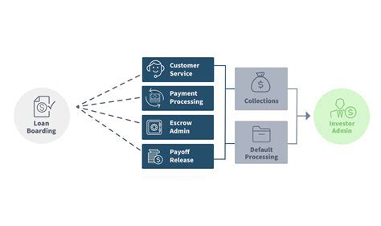

* Loan servicing refers to delayed payment collection on the loan and further dispersion to concerned parties.
* The **loan servicing specialist**manages prompt debt payment collection and, in turn, receives a minimum proportion of the compensation to be paid by the borrower.
* It assists in preventing complex loans and fostering a healthy relationship between the defaulter and financial institution. Though applied to every type of loan, mortgages are the most used.
* It incorporates payment processing, sending monthly balance statements, maintaining bill records, and replying to requests.

**7. Loan Servicing System – Interest rate management –**

Interest Rate Risk Assessment:

* Conduct a thorough analysis of the interest rate risk exposure in the financial portfolio.
* Identify and quantify potential risks associated with changes in interest rates.

Types of Interest Rate Risk:

* Price Risk: The potential for changes in market interest rates to affect the value of existing financial instruments.
* Reinvestment Risk: The risk that cash flows from existing investments will be reinvested at lower interest rates.
* Basis Risk: The risk that the relationship between different interest rates (e.g., short-term and long-term rates) will change.

Financial Instruments and Assets:

* Evaluate the sensitivity of various financial instruments to interest rate changes.
* Consider the impact on loans, bonds, mortgages, and other interest-sensitive assets.

Hedging Strategies:

* Implement hedging instruments, such as interest rate swaps, options, or futures, to mitigate interest rate risk.
* Design hedging strategies aligned with the specific risk exposures of the organization.

Diversification:

* Diversify the composition of the investment portfolio to spread interest rate risk.
* Invest in a mix of short-term and long-term assets to balance potential impacts.

Interest Rate Forecasting:

* Stay informed about economic indicators and factors that influence interest rate movements.
* Use forecasting models and analysis to anticipate future interest rate trends.

Scenario Analysis:

* Conduct scenario analysis to assess the potential impact of different interest rate scenarios on the financial portfolio.
* Evaluate the resilience of the portfolio under various economic conditions.

Liquidity Management:

* Ensure that sufficient liquidity is available to meet obligations, especially in periods of rising interest rates.
* Manage cash flows effectively to address potential challenges.

Regulatory Compliance:

* Stay compliant with regulatory requirements related to interest rate risk management.
* Adhere to guidelines set by regulatory bodies regarding disclosure and reporting.

Communication and Transparency:

* Communicate interest rate risk management strategies and outcomes transparently to stakeholders.
* Provide clear information about how interest rate changes may impact financial performance.

**7. Debt Management System – Basic concepts Stages of collections –**

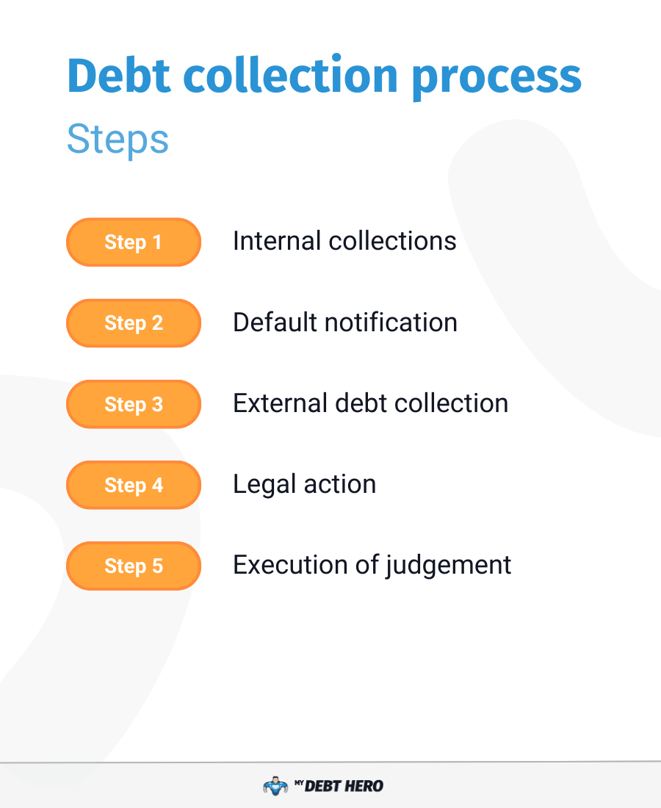

**8. Debt Management – Queueing, Allocation, Work List & Trail Capture –**

**Queueing:**

* Definition:

Queueing in a DMS involves the systematic organization of tasks or cases into queues based on certain criteria.

* Purpose:

1. Prioritize tasks based on urgency, severity, or specific criteria.
2. Ensure a fair and consistent distribution of workload among debt management personnel.

* Functionality:

1. Assign tasks to different queues based on predefined rules or criteria.
2. Establish priority levels for each queue to guide debt management staff on task urgency.
3. Automate the process of moving tasks between queues based on changes in criteria or statuses.

**Allocation:**

* Definition:

Allocation refers to the assignment of specific tasks or cases to individual debt management agents or teams.

* Purpose:

1. Ensure accountability by assigning tasks to specific individuals or teams.
2. Optimize workload distribution based on the skillset or expertise of debt management staff.

* Functionality:

1. Automatically allocate tasks based on predefined rules, such as workload, skill levels, or performance metrics.
2. Allow manual allocation by supervisors or administrators for more personalized task assignments.
3. Monitor workload distribution to prevent bottlenecks or uneven workloads among team members.

**Work List Management:**

* Definition:

Work list management involves the organization and presentation of tasks or cases to debt management staff in a user-friendly format.

* Purpose:

1. Facilitate easy access to assigned tasks.
2. Provide a consolidated view of pending and completed work for each debt management agent.

* Functionality:

1. Create personalized work lists for each debt management agent based on their allocated tasks.
2. Include relevant details such as debtor information, outstanding amounts, and task statuses.
3. Implement filters and sorting options to help agents prioritize and navigate their work lists efficiently.

**Trail Capture:**

* Definition:

Trail capture involves recording and documenting the activities and decisions made during the debt management process.

* Purpose:

1. Establish a transparent and auditable record of interactions with debtors.
2. Provide a historical trail for compliance, dispute resolution, or legal purposes.

* Functionality:

1. Automatically capture and log relevant interactions, communications, and decisions made during the debt management process.
2. Include timestamps, user identifiers, and system-generated notes in the trail.
3. Ensure that the trail is accessible and can be easily retrieved for reporting, auditing, or legal purposes.

* CUSTOMER ONBOARDING

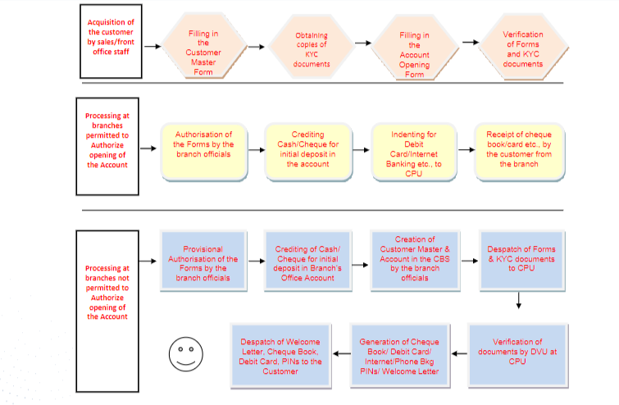

**1. Traditional Approach for Customer Onboarding**

1. **In-Person Visits:**
   * Customers visit a physical branch of the bank to open an account or inquire about financial products and services.
   * Bank representatives assist customers in understanding the available account types and gathering necessary documentation.
2. **Paper-Based Documentation:**
   * Customers are required to fill out paper-based application forms and provide supporting documents, such as proof of identity, proof of address, and other relevant information.
   * The documentation typically includes a signature, indicating the customer's consent and agreement to the terms and conditions.
3. **Verification of Identity:**
   * Bank staff manually verify the customer's identity by checking the provided documents and cross-referencing them with external databases, if applicable.
   * In some cases, a customer may need to present additional identification, such as a passport or driver's license.
4. **Credit Checks and Approval:**
   * For certain financial products, such as loans or credit cards, banks may conduct credit checks to assess the customer's creditworthiness.
   * The approval process is often manual, with bank personnel reviewing the customer's financial history and making decisions based on established criteria.
5. **Account Activation:**
   * Once the application is approved, the customer's account is activated, and they receive physical account details, such as account number and checks.
   * The customer may also receive a welcome kit containing relevant information about the bank's services and policies.
6. **Educating the Customer:**
   * Bank representatives provide in-person guidance to customers, explaining account features, services, and any associated fees.
   * Customers may be informed about how to access online or mobile banking services if available.
7. **Issuance of Physical Documents:**
   * Physical documents, such as passbooks, checkbooks, and account statements, are provided to the customer.
   * The customer may also be issued a physical debit or credit card.
8. **In-Person Service Requests:**
   * Any subsequent service requests, such as updating account information or applying for additional products, may require the customer to visit a branch in person.
9. **Follow-Up and Relationship Building:**
   * Banks may engage in periodic follow-ups with customers to ensure satisfaction, address concerns, and offer additional products or services.
   * Relationship managers or customer service representatives may maintain personal contact with customers.

**2. Current Challenges for Customer Onboarding**

1. **Regulatory Compliance:**
   * **Challenge:** Stringent and evolving regulations create complexities in ensuring compliance throughout the onboarding process.
   * **Impact:** Banks must invest in robust systems to navigate compliance requirements, leading to increased costs and potential delays.
2. **Identity Verification:**
   * **Challenge:** Verifying customer identities accurately while avoiding fraud remains a challenge, especially in digital onboarding.
   * **Impact:** Incorrect identity verification can lead to security issues, financial losses, and regulatory penalties.
3. **Data Security and Privacy:**
   * **Challenge:** Safeguarding customer data during onboarding is critical, considering the increasing frequency of data breaches.
   * **Impact:** Data breaches erode customer trust and may result in reputational damage and legal consequences.
4. **Customer Experience:**
   * **Challenge:** Balancing stringent security measures with a seamless and user-friendly onboarding experience is challenging.
   * **Impact:** Cumbersome onboarding processes can lead to customer frustration, abandonment, and a negative perception of the bank.
5. **Fragmented Systems and Processes:**
   * **Challenge:** Legacy systems and fragmented processes hinder the creation of a streamlined and integrated onboarding experience.
   * **Impact:** Inefficiencies, errors, and delays in onboarding due to disjointed systems can negatively impact operational effectiveness.
6. **Digital Onboarding Adoption:**
   * **Challenge:** Shifting from traditional to digital onboarding poses challenges in terms of technology adoption, user education, and ensuring inclusivity.
   * **Impact:** Banks may struggle to keep up with competitors offering more advanced and convenient digital onboarding experiences.
7. **Document Management:**
   * **Challenge:** Handling and verifying a myriad of documents submitted during onboarding, especially in paper-based processes, can be time-consuming and error-prone.
   * **Impact:** Manual document processing may lead to delays, errors, and increased operational costs.
8. **Risk Management:**
   * **Challenge:** Assessing and managing risks associated with new customers, especially in areas such as credit risk, remains a challenge.
   * **Impact:** Inadequate risk assessment can result in financial losses and adversely impact the bank's overall risk profile.
9. **Cross-Border Onboarding:**
   * **Challenge:** Onboarding customers across borders involves navigating different regulatory environments and compliance standards.
   * **Impact:** Cross-border onboarding may lead to delays, increased costs, and challenges in maintaining consistency across jurisdictions.
10. **Technological Integration:**
    * **Challenge:** Integrating new technologies seamlessly with existing infrastructure is a common obstacle.
    * **Impact:** Incomplete or inefficient integration may hinder the effectiveness of digital onboarding solutions.
11. **Monitoring and Reporting:**
    * **Challenge:** Establishing effective monitoring and reporting mechanisms to track onboarding processes and identify areas for improvement.
    * **Impact:** Without proper monitoring, banks may struggle to identify bottlenecks, compliance issues, or inefficiencies in the onboarding workflow.

**3. Digital Approach to Customer Onboarding**

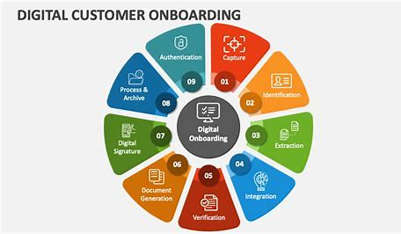

**4. Types of Digital Identity Checks**

1. **Document Verification:**
   * **Description:** Customers submit scanned copies or images of identity documents such as passports, driver's licenses, or national ID cards.
   * **Process:** Automated systems analyze and verify the authenticity of the document, checking for watermarks, security features, and overall consistency.
2. **Biometric Authentication:**
   * **Description:** Biometric data, such as fingerprints, facial recognition, or voice recognition, is used to verify the customer's identity.
   * **Process:** Customers capture biometric information using dedicated devices, cameras, or mobile devices, and the system compares it with pre-enrolled biometric data.
3. **Knowledge-Based Authentication (KBA):**
   * **Description:** Customers answer knowledge-based questions related to personal information, such as addresses, previous transactions, or other details.
   * **Process:** Questions are generated based on publicly available information and credit history, and correct answers help verify the customer's identity.
4. **Two-Factor Authentication (2FA) or Multi-Factor Authentication (MFA):**
   * **Description:** In addition to a password or PIN, customers must provide a second or multiple forms of authentication.
   * **Process:** Common factors include one-time passwords (OTPs) sent to mobile devices, authentication apps, or physical tokens.
5. **Social Media Verification:**
   * **Description:** Leveraging social media profiles and activities to corroborate identity details.
   * **Process:** Customers grant permission for the bank to access and analyze their social media accounts, ensuring consistency with the provided information.
6. **Video KYC (Know Your Customer):**
   * **Description:** Customers participate in live video sessions with bank representatives for identity verification.
   * **Process:** The bank representative interacts with the customer, reviews identity documents, and validates the customer's identity in real-time.
7. **Device-based Authentication:**
   * **Description:** Utilizing the characteristics of the device used for access, such as the device's location, IP address, and device fingerprint.
   * **Process:** The system checks the device attributes and compares them with known patterns associated with the customer's previous interactions.
8. **Blockchain Identity Verification:**
   * **Description:** Leveraging blockchain technology to secure and verify customer identity details.
   * **Process:** Customer identity information is stored on a blockchain, ensuring data integrity, security, and transparency.
9. **Behavioural Biometrics:**
   * **Description:** Analysing user behaviour patterns, such as typing speed, mouse movements, or touchscreen gestures.
   * **Process:** The system builds a profile of the customer's behavioural characteristics over time, using this data for continuous authentication.
10. **Remote Online Notary Services:**
    * **Description:** Enabling customers to get documents notarized remotely through online notary services.
    * **Process:** A notary public conducts the notarization process via video conferencing, confirming the customer's identity.
11. **Government Databases and Eid Verification:**
    * **Description:** Accessing government databases or electronic ID systems to verify customer identity details.
    * **Process:** The system cross-references customer-provided information with data from official government records.
12. **Mobile Network Operator (MNO) Verification:**
    * **Description:** Using data provided by mobile network operators to verify customer identity.
    * **Process:** The bank accesses information from the customer's mobile network operator to validate identity details.

**5. KYC**

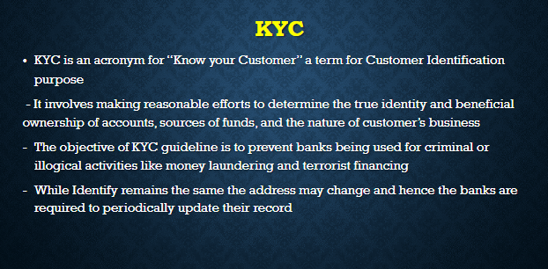

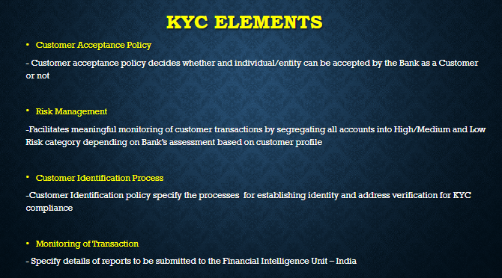

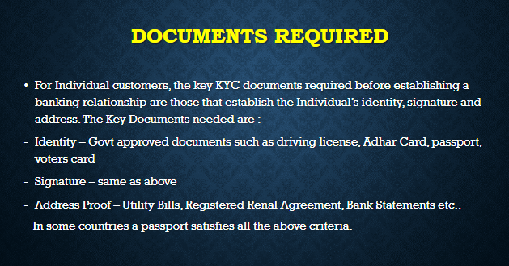

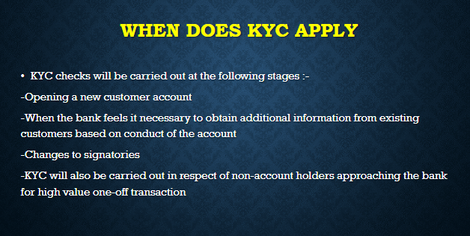

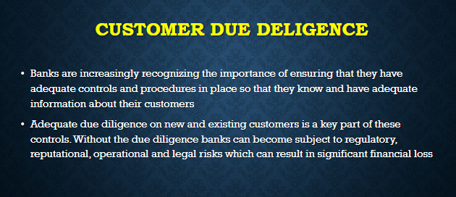

**5. Aadhar Enabled Validations**

RBI has updated its OVD (Officially Valid Documents) list and has added “Proof of possession of Aadhaar number” for opening a bank account. OVDs are those documents that a customer has to provide when he applies for a new bank account. However, applicants can use their [Aadhaar card](https://www.paisabazaar.com/aadhar-card/) for identity and address verification on a voluntary basis only.

**6. Corporate KYC Onboarding**

**WHAT IS CORPORATE KYC?**  **What is Corporate KYC?**

**Corporate KYC**, also known as KYC of Company, is the process of screening a business or corporate body and its beneficiary owners for **AML/KYC compliance**. This blog article will teach you about KYC Requirements for Corporates, the Corporate KYC process, what information a corporate client must submit, and how corporate **KYC procedures** may be automated using simple technologies. **A**

**WHY IS CORPORATE KYC IMPORTANT? Eo**

During **client onboarding**, it is critical to understand who your customer is in order to detect any possible hazards they may offer in a business partnership. The worldwide community has been broadening the scope of KYC requirements in order to combat money laundering, financial crime, and other illicit activities, requiring banks and companies to comply with new standards that are more strict than ever before. This information is often found on company registration paperwork, which are frequently available online. If corporate KYC becomes too time-consuming, you might hire a corporate **KYC service**.

## ****O CORPORATE KYC CHALLENGES KYC: The Challenges****‍

Individual KYC procedures are less extensive, complicated, and expensive than corporate KYC procedures. The following are some of the most significant problems involved with the corporate KYC process:

#### **Poor Data**

When attempting to verify a corporate customer’s KYC information in another jurisdiction, any financial institution will encounter errors and inconsistencies in company registration records and filing histories. Because financial organisations rely on data to make decisions, erroneous data may be harmful.

#### **Positive Errors**

When investigating a false positive, regulated enterprises incur significant costs, even though such inquiries are typically unwarranted. Firms face harsh fines from the regulation if they fail to do rigorous PEP and sanctions screening (even if the screening is a false positive).

#### **Onboarding is time**-consuming and generally manual.

The real money and resources required to screen potential customers prior to**user onboarding** are a constant source of worry for financial institutions and businesses adopting **corporate KYC**. Because of the time and effort required, the onboarding institution and potential client may abandon the project, or the business client may opt not to onboard.

#### **Constant monitoring**

After a consumer is onboarded, the corporate KYC problems persist. Firm structures, ownership, and commercial interests are all subject to change. As a result, a business that successfully completed a**KYC check** during onboarding may not be compliant in the future. Because of the ever-changing nature of **AML/CTF regulation** throughout the world, banking, financial services, and insurance (BFSIs) may need to reclassify existing customers who were previously deemed low risk.

## ****KYC Requirements for Corporates****

#### **What are the required documents for Corporate** KYC?

The most crucial papers that a firm must supply during **corporate KYC** are as follows:

* Tax identification numbers
* Beneficiary information (passport, government-issued IDs, etc.)
* Trustees’ List
* Copy of the incorporation certificate
* Bank statements and income tax returns
* BANKING ARCHITECTURE

**1. Banking Architecture Overview & Legacy**

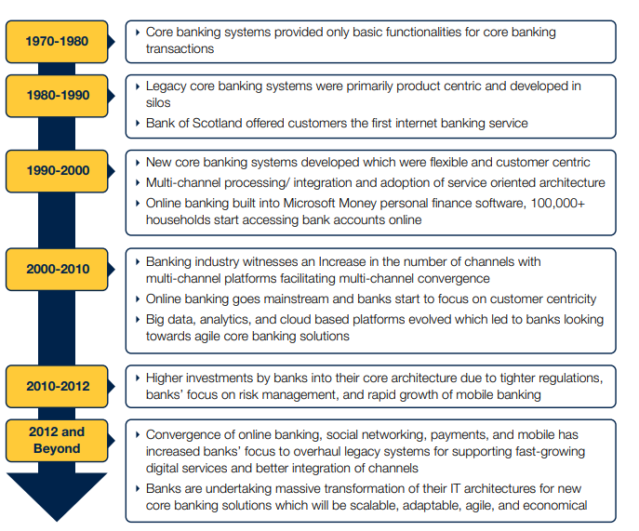

**2. Modern Day Architecture**

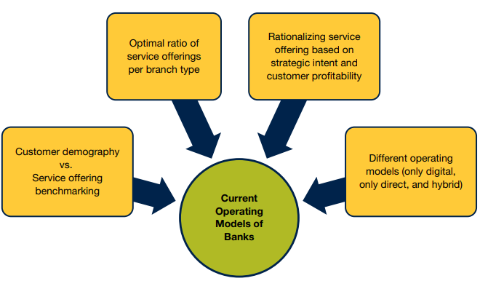

**3. Simplifying Banking Architecture**

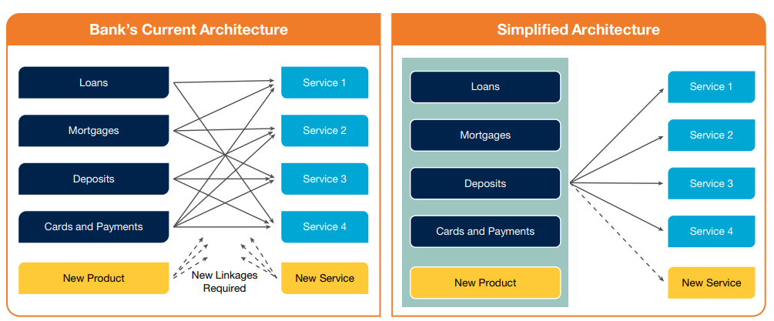

**4. Operating in a Simplified Banking Architecture**

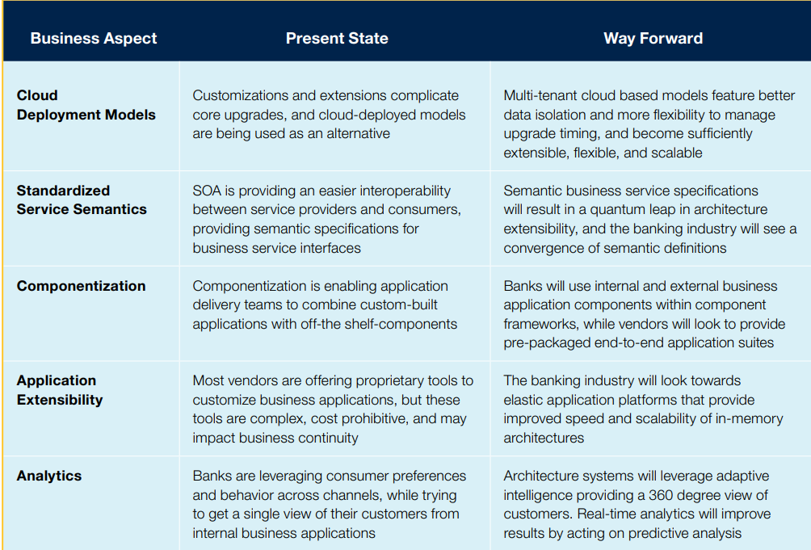

**5. Recommendations for Banks**

* Invest in Digital Transformation
* Adopt Open Banking Practices
* Enhance Cybersecurity Measures
* Improve Customer Engagement
* Streamline Onboarding Processes
* Focus on Regulatory Compliance
* Optimize Operational Efficiency
* Invest in Analytics and Business Intelligence
* Promote Financial Inclusion
* Collaborate with Fintech
* Prioritize Sustainability and ESG Initiatives
* Cultivate a Culture of Innovation
* Upgrade Core Banking Systems
* Emphasize Customer Education
* Build Resilience to Disruptions
* Stay Agile and Responsive
* PAYMENTS

**1. Introduction to Payments**

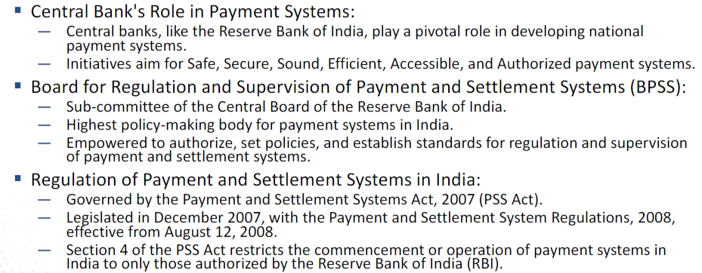

**2. Classification of Payments Methods**

* **By Nature of Transaction:**
* Cash Payments
* Electronic Payments
* Card Payments

Credit Cards

Debit Cards

Prepaid Cards

Bank Transfers

Digital Wallets

Cryptocurrency Payments

* **By Technology Used:**
* Contactless Payments
* Mobile Payments
* QR Code Payments
* Biometric Payments
* **By Entities Involved:**
* Person-to-Person (P2P) Payments
* Business-to-Consumer (B2C) Payments
* Consumer-to-Business (C2B) Payments
* Business-to-Business (B2B) Payments
* **By Geography:**
* Domestic Payments
* International Payments
* **By Timing:**
* Real-Time Payments
* Deferred Payments
* **By Funding Source:**
* Credit Payments
* Debit Payments
* Prepaid Payments
* **By Security Features:**
* Secure Payments
* Non-Secure Payments
* **By Regulatory Framework:**
* Regulated Payments
* Unregulated Payments

**3. Payments Systems & Types**

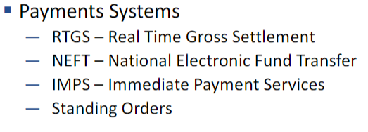

* **RTGS**

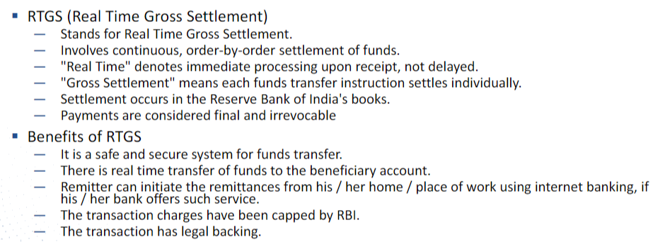

* **NEFT**

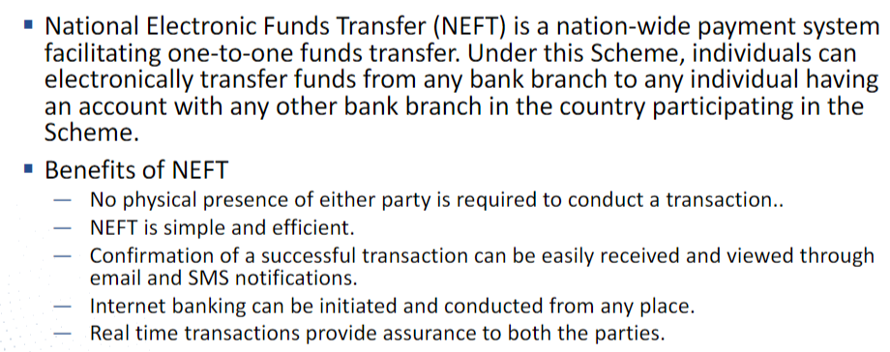

* **IMPS**

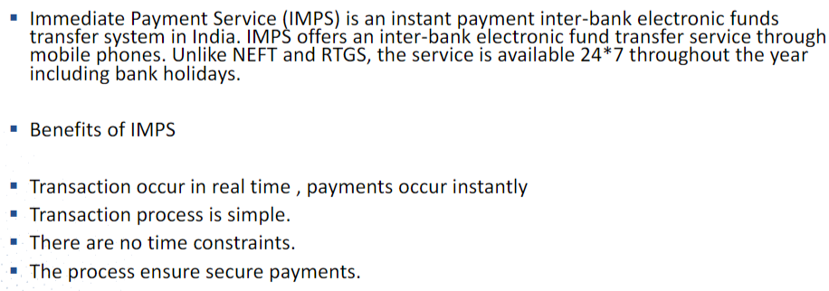

* **STANDING ORDER**

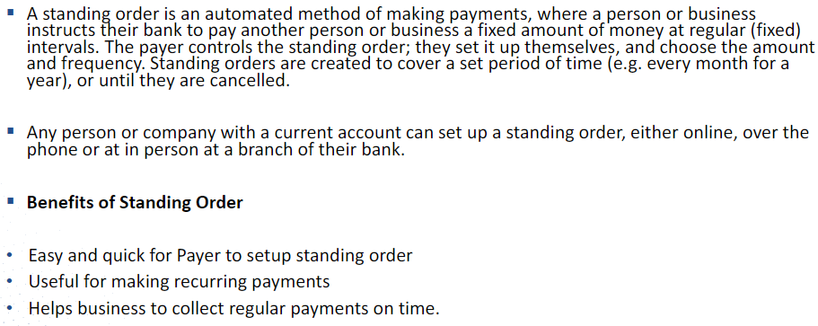

* **SWIFT**

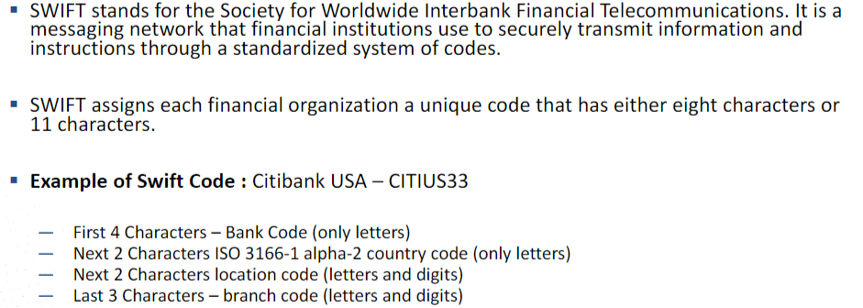

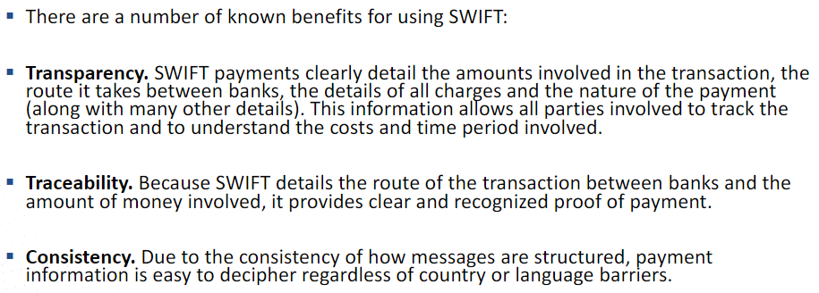

**4. Payments Systems Architecture**

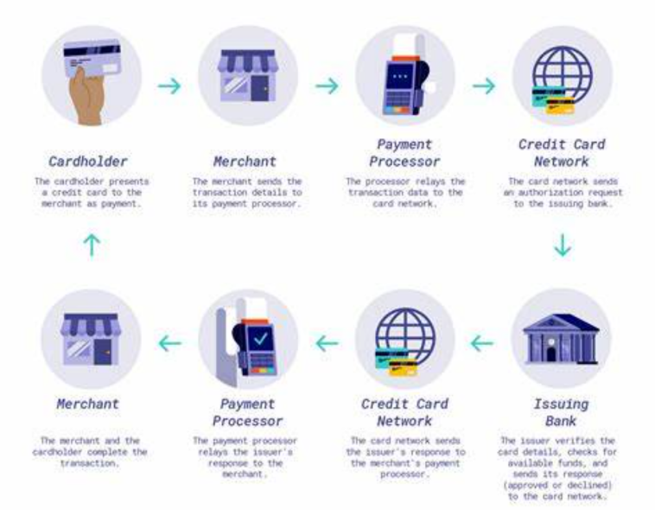

**5. Money Laundering**

Money laundering is the illegal process of making large amounts of money generated by criminal activity, such as drug trafficking or terrorist funding, appear to have come from a legitimate source. The money from the criminal activity is considered dirty, and the process “launders” it to make it look clean.

* **Stages in Money Laundering**

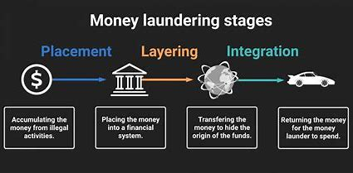

* CORPORATE BANKING

**1. Corporate Banking Overview**

Corporate banking, also known as business banking or commercial banking, is a specialized banking service that caters to the financial needs of corporations, businesses, and other large entities. Corporate banking involves a range of financial products and services tailored to meet the unique requirements of businesses, helping them manage their finances, optimize cash flow, and achieve their strategic goals. Here's an overview of corporate banking:

**Key Services and Products in Corporate Banking:**

1. **Business Loans and Credit:**
   * **Term Loans:** Fixed-term loans for specific business purposes, often used for capital expenditures.
   * **Working Capital Loans:** Short-term loans to fund day-to-day operational expenses.
   * **Revolving Credit Lines:** Flexible credit lines that businesses can draw upon as needed.
2. **Commercial Real Estate Financing:**
   * Loans and financing for purchasing, refinancing, or developing commercial properties.
3. **Treasury and Cash Management:**
   * **Cash Concentration:** Consolidation of funds from multiple accounts into a central account.
   * **Payment Services:** Facilitation of domestic and international payments.
   * **Collections:** Services for efficient receivables and collections management.
4. **Trade Finance:**
   * **Letters of Credit:** Financial instruments ensuring payment to exporters.
   * **Trade Financing:** Providing financing for importers and exporters involved in international trade.
5. **Foreign Exchange Services:**
   * Facilitating currency exchange and hedging against currency risk for businesses involved in international transactions.
6. **Deposit Services:**
   * **Business Checking and Savings Accounts:** Accounts tailored to business needs.
   * **Certificates of Deposit (CDs):** Time deposits with fixed interest rates.
7. **Commercial Cards:**
   * Corporate credit cards and purchasing cards for streamlined business expenses.
8. **Risk Management:**
   * **Interest Rate Hedging:** Strategies to manage interest rate risk.
   * **Derivatives:** Financial instruments used to hedge against various risks.
9. **Merchant Services:**
   * Payment processing services for businesses, including card payments and online transactions.
10. **Employee Benefits Services:**
    * Offering retirement plans, employee stock ownership plans (ESOPs), and other benefits.
11. **Advisory Services:**
    * **Corporate Finance:** Assistance with mergers and acquisitions, capital raising, and financial restructuring.
    * **Treasury Advisory:** Guidance on optimizing cash flow and liquidity management.
12. **Online Banking Platforms:**
    * Robust digital platforms for businesses to manage their accounts, conduct transactions, and access financial information.

**2. Retail vs Corporate Banking**

**1. Target Customer:**

* **Retail Banking:**
  + **Customer Base:** Individuals, families, and small businesses.
  + **Focus:** Services are designed for the general public, catering to personal financial needs.
* **Corporate Banking:**
  + **Customer Base:** Large corporations, businesses, and institutional clients.
  + **Focus:** Services are tailored to meet the complex financial requirements of businesses, ranging from small enterprises to multinational corporations.

**2. Scope of Services:**

* **Retail Banking:**
  + **Products and Services:** Savings accounts, checking accounts, personal loans, mortgages, credit cards, and basic investment products.
  + **Focus Areas:** Personal finance, home ownership, education, and day-to-day banking needs.
* **Corporate Banking:**
  + **Products and Services:** Business loans, commercial real estate financing, treasury and cash management, trade finance, risk management, and corporate advisory services.
  + **Focus Areas:** Working capital management, expansion financing, international trade facilitation, and strategic financial planning.

**3. Transaction Size:**

* **Retail Banking:**
  + **Transaction Size:** Typically involves smaller transactions, such as individual deposits, small loans, and retail purchases.
* **Corporate Banking:**
  + **Transaction Size:** Involves larger and more complex transactions, including significant loan amounts, international trade deals, and large-scale financing.

**4. Relationship Management:**

* **Retail Banking:**
  + **Customer Interaction:** Generally transactional, with limited personalization.
  + **Relationship Managers:** Minimal need for dedicated relationship managers.
* **Corporate Banking:**
  + **Customer Interaction:** Relationship-driven, with a focus on understanding the unique needs of each corporate client.
  + **Relationship Managers:** Dedicated relationship managers work closely with corporate clients to provide tailored financial solutions.

**5. Risk Exposure:**

* **Retail Banking:**
  + **Risk Profile:** Lower risk exposure due to smaller transaction sizes and a diverse customer base.
  + **Credit Risk:** Primarily associated with personal loans and credit cards.
* **Corporate Banking:**
  + **Risk Profile:** Higher risk exposure due to larger transaction sizes and interconnected financial relationships.
  + **Credit Risk:** Significant exposure to credit risk associated with large business loans and financial services.

**6. Regulatory Environment:**

* **Retail Banking:**
  + **Regulation:** Subject to regulations aimed at consumer protection and financial stability.
* **Corporate Banking:**
  + **Regulation:** Subject to additional regulatory requirements and scrutiny due to the potential systemic impact of large corporate failures.

**7. Technology Adoption:**

* **Retail Banking:**
  + **Technology Focus:** Emphasis on user-friendly digital interfaces, online banking, and mobile banking for retail customers.
* **Corporate Banking:**
  + **Technology Focus:** Integration of sophisticated technology for treasury management, cash flow optimization, and risk management solutions.

**8. Financial Planning:**

* **Retail Banking:**
  + **Financial Planning:** Typically involves basic financial planning for individual goals such as education, home purchase, and retirement.
* **Corporate Banking:**
  + **Financial Planning:** In-depth financial planning and strategic advisory services to support business growth and sustainability.

**9. Market Dynamics:**

* **Retail Banking:**
  + **Competitive Dynamics:** Highly competitive, with a focus on attracting and retaining individual customers.
* **Corporate Banking:**
  + **Competitive Dynamics:** Intense competition for large corporate clients, often involving customized financial solutions and relationship-based services.

**3. Corporate Banking Products -**

1. Business Loans and Credit:

• Term Loans

• Working Capital Loans

2.        Commercial Real Estate Financing

3.        Trade Finance:

• Letters of Credit

• Trade Financing

4.        Treasury and Cash Management:

• Cash Concentration

• Payment Services

• Collections

5.        Foreign Exchange Services

6.        Deposit Services:

• Business Checking and Savings Accounts

• Certificates of Deposit (CDs)

7.        Commercial Cards:

• Corporate Credit Cards

• Purchasing Cards

8.        Risk Management:

• Interest Rate Hedging

• Derivatives

9.        Merchant Services:

• Payment Processing

10.        Employee Benefits Services

11.        Advisory Services:

• Corporate Finance

• Treasury Advisory

12.        Online Banking Platforms

13.        Customized Financial Solutions

14.        Commercial Insurance Services

15.        Escrow Services

16.        Supply Chain Financing

17.        Online and Mobile Banking Security

* WEALTH MANAGEMENT

**1. Mutual Funds -**

An investment vehicle that pools money from multiple investors to invest in a diversified portfolio of stocks, bonds, or other securities, managed by professional fund managers.

### Structure:

* **Open-End Funds:**
  + Can issue an unlimited number of shares.
  + Redemptions and purchases are made directly with the fund.
* **Closed-End Funds:**
  + Limited number of shares.
  + Trades on exchanges like a stock.

**Types of Mutual Funds:**

1. **Equity Funds:**
   * Invest in stocks, offering growth potential.
2. **Fixed-Income Funds:**
   * Invest in bonds, providing income with lower risk.
3. **Money Market Funds:**
   * Invest in short-term, low-risk securities.
   * Aim for capital preservation.
4. **Balanced or Hybrid Funds:**
   * Combine stocks and bonds for a balanced approach.
5. **Index Funds:**
   * Mirror a specific market index, aiming to replicate its performance.
6. **Sector Funds:**
   * Concentrate on specific industries or sectors.

**Advantages:**

* **Diversification:**
  + Instantly own a variety of securities.
* **Professional Management:**
  + Managed by experienced fund managers.
* **Liquidity:**
  + Easily buy or sell shares at the end of the trading day.
* **Accessibility:**
  + Access to various asset classes with a relatively low investment.

**Considerations:**

* **Fees:**
  + Expense Ratio: Annual fee as a percentage of assets.
  + Sales Load: Commission paid when buying or selling.
* **Risk:**
  + Subject to market fluctuations.
  + Past performance is not indicative of future results.
* **Tax Implications:**
  + Capital gains distributions may have tax consequences.
* **Benchmark Comparison:**
  + Assess fund performance relative to a benchmark.

**How to Invest:**

1. **Select a Fund:**
   * Based on financial goals, risk tolerance, and investment horizon.
2. **Open an Account:**
   * Through a brokerage or directly with the fund.
3. **Investment Amount:**
   * Initial investment and subsequent contributions.
4. **Redeem or Reinvest:**
   * Choose to receive profits or reinvest them.

**Regulation:**

* **Regulated by:**
  + Securities and Exchange Commission (SEC) in the United States.

**Key Metrics:**

* **Net Asset Value (NAV):**
  + Price per share, calculated daily after market close.
* **Total Return:**
  + Includes capital appreciation and dividends or interest.

**2. Equities -**

* **Definition:**
  + Represent ownership in a company.
* **Characteristics:**
  + Ownership entitles shareholders to a portion of company assets and profits.
  + Returns come from stock price appreciation and dividends.
* **Types:**
  + Common Stock: Basic ownership rights, voting privileges.
  + Preferred Stock: Preference in dividends but usually no voting rights.
* **Risk and Return:**
  + Higher risk and potential returns compared to bonds.
  + Prices fluctuate based on market conditions and company performance.
* **Market Participation:**
  + Traded on stock exchanges.
  + Investors can buy and sell shares to other investors.
* **Issuer Obligations:**
  + No fixed interest payments.
  + Companies pay dividends at their discretion.

**3. Bonds -**

* **Definition:**
  + Debt securities representing a loan to an issuer.
* **Characteristics:**
  + Fixed interest payments (coupon) to bondholders.
  + Return of principal at maturity.
* **Types:**
  + Government Bonds: Issued by governments.
  + Corporate Bonds: Issued by companies.
  + Municipal Bonds: Issued by local governments.
* **Risk and Return:**
  + Generally lower risk compared to equities.
  + Fixed interest payments provide steady income.
* **Market Participation:**
  + Traded in the bond market.
  + Investors buy bonds from issuers or other investors.
* **Issuer Obligations:**
  + Legal obligation to pay interest and return principal.
  + Default risk varies based on issuer creditworthiness.
* **Consideration for Equity & Bonds**
* **Diversification:**
  + Building a portfolio with a mix of equities and bonds can reduce overall risk.
* **Income and Growth:**
  + Equities: Potential for capital appreciation.
  + Bonds: Generate income through fixed interest payments.
* **Market Conditions:**
  + Equities: Perform well in growing economies.
  + Bonds: May be attractive during economic uncertainties.
* **Investor Goals:**
  + Equities suit those seeking growth and willing to accept higher volatility.
  + Bonds suit those prioritizing income and capital preservation.